 | INDIAN INSTITUTE OF TECHNOLOGY ROORKEE
Programming with C and C++ (CSC-101)

Assignment 7 100 marks

Garv
25114035

Q-1) Given an array of size n and the numbers in the array are from [1, n-1]. One of the elements in the array is repeated. So return the number in the array which is repeated. Try to solve it without using a nested loop.
For example: n=5, arr = [2, 3, 4, 1, 1]
Output: 1
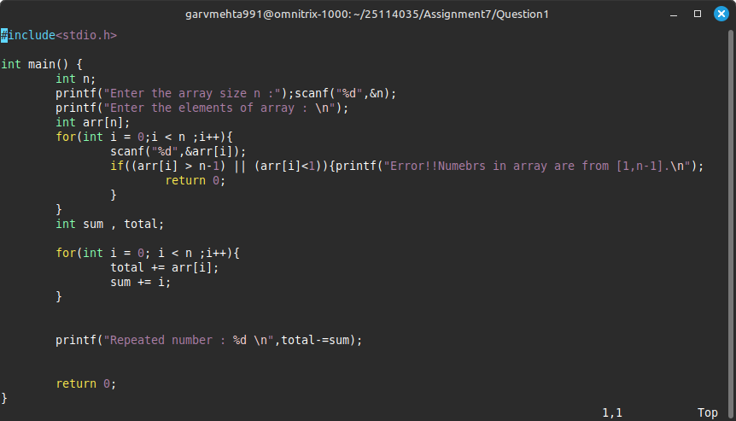

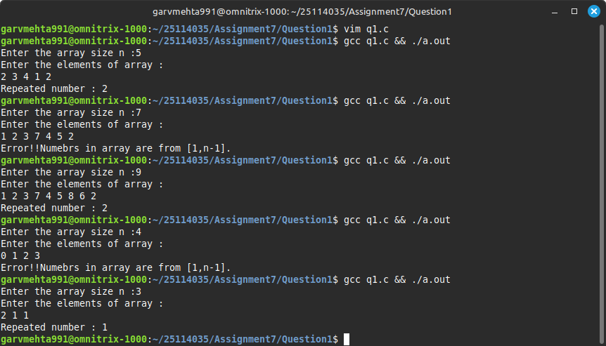

Q-2) Given an integer array nums return true if any value appears at least twice in the array and return false if all the elements are distinct.
Example: nums = [10, 20, 30, 40, 10]
Output = True
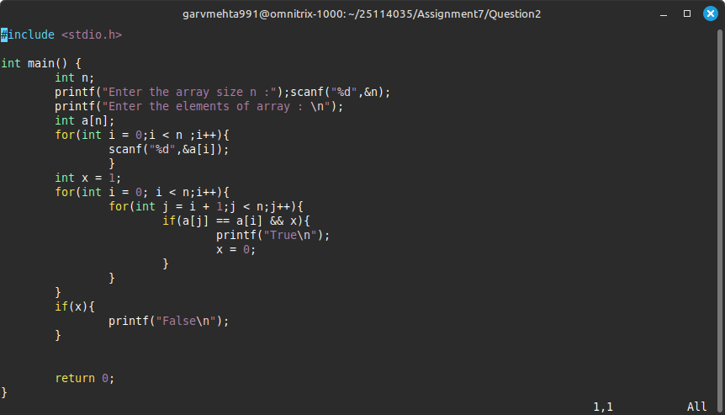

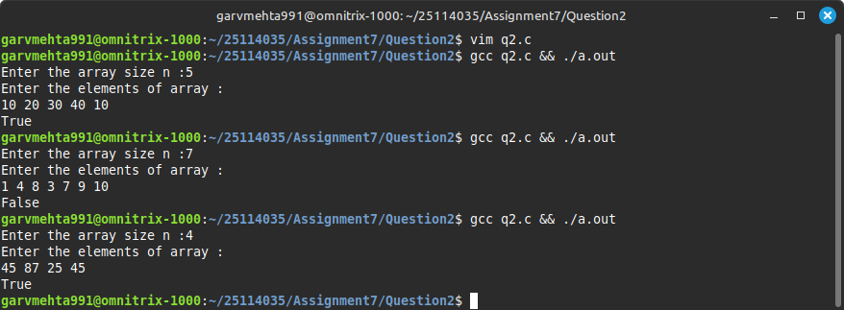

Q-3) Write a program that finds the Union and intersection of two arrays (elements that are present in both arrays) and stores it in a new array.
Input: arr1[] = {7, 1, 5, 2, 3, 6}
arr2[] = {3, 8, 6, 20, 7}
Output : Union - {1, 2, 3, 5, 6, 7, 8, 20}
Intersection as {3, 6, 7}
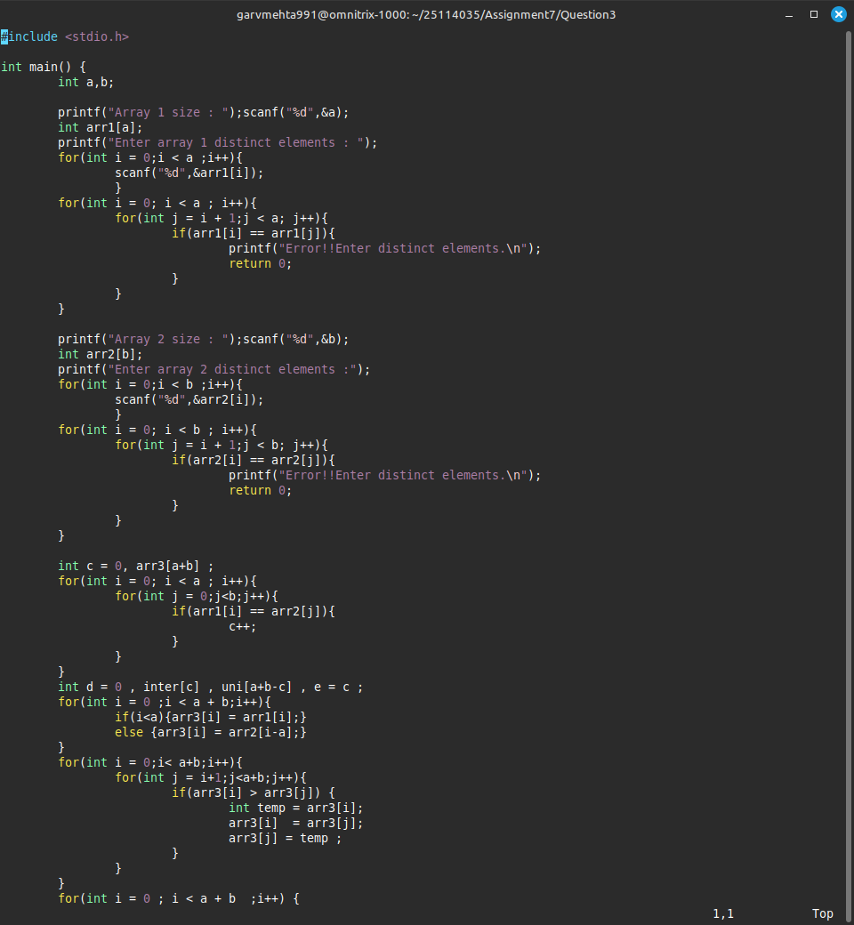

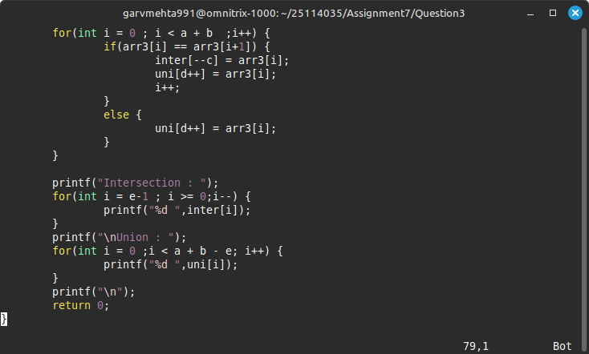

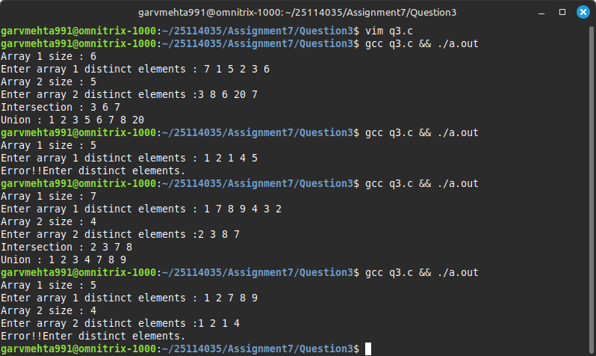

Q-4) Write a C program to remove the element from the array and shift the rest.

Input: {1, 2, 3, 5, 6, 7, 8, 20}
Output: {1, 2, 5, 6, 7, 8, 20}
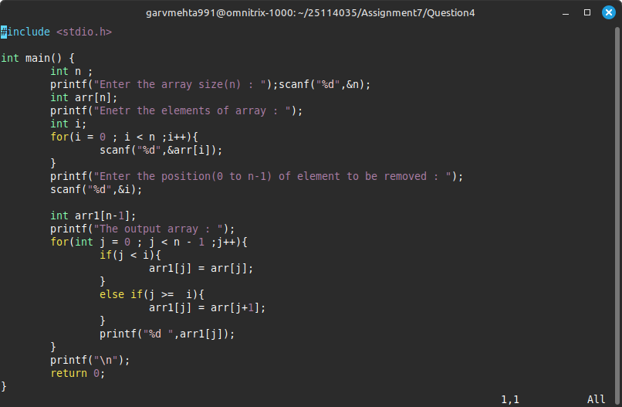

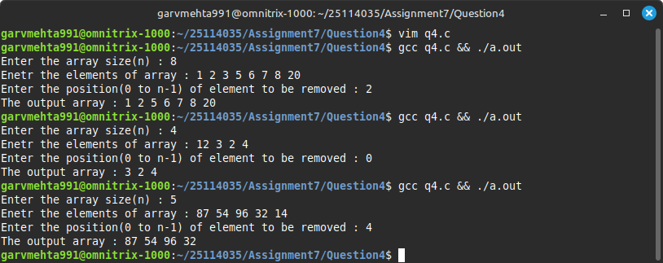

Q-5) You have been given two unsorted arrays. Write a C program to merge the unsorted array into a single sorted array.
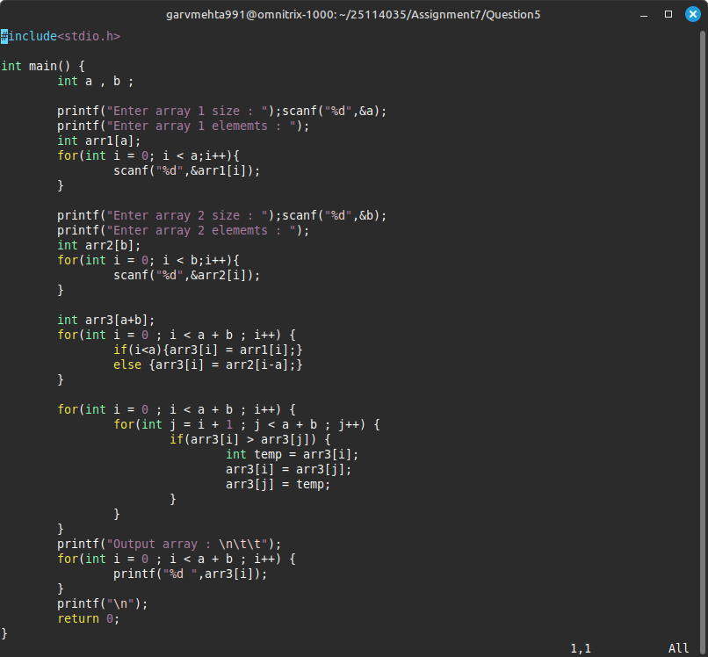

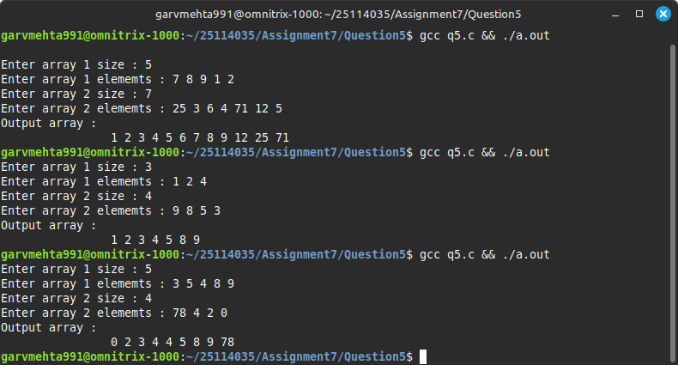

Q-6) Write a program to apply circular right shift by “K” positions on an array A and store the result in a new array B and print the content of B. Here the array and the value n should be user input. Ex: Input: A[5] = 2 3 4 -1 0 , k = 2
Output: B[5] = -1 0 2 3 4
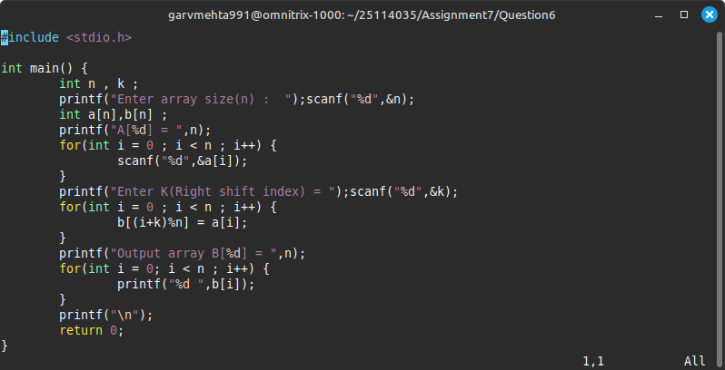

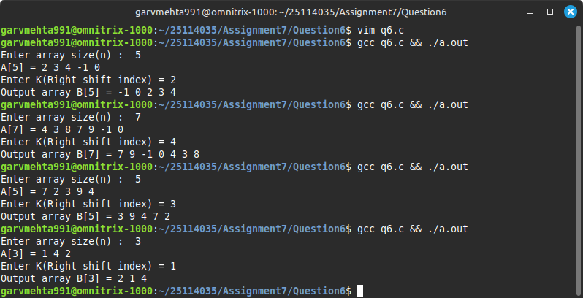

Q-7) A temperature monitoring system collects sensor readings every minute and stores them in an array. However, due to occasional glitches, some readings are clearly incorrect (e.g., sudden spikes or dips). Your task is to smooth the data by replacing every anomalous reading with the average of its two neighbors, but only if the anomaly is detected. An anomaly is defined as a reading that differs from the average of its two neighbors by more than a given threshold T.
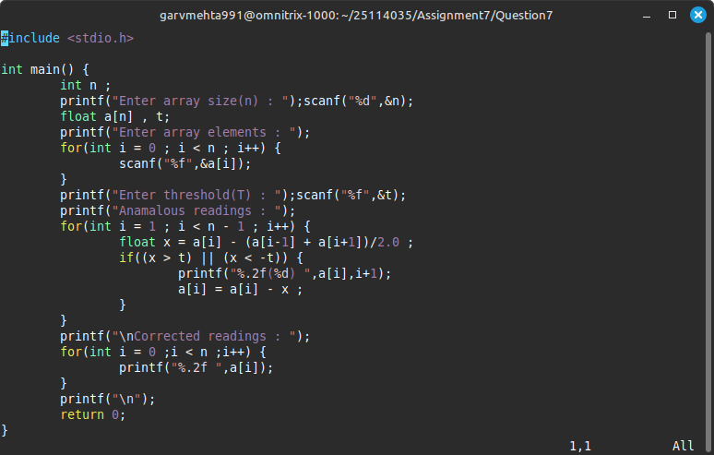

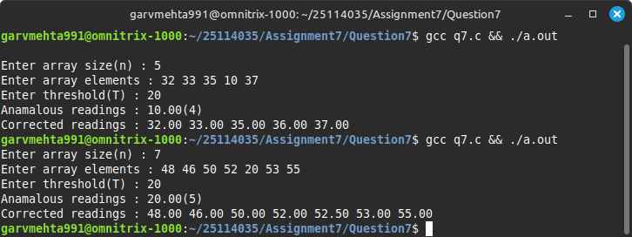

Q-8) You are given a time-series array representing the number of cars entering (+ve) or leaving (-ve) a parking lot. Find the peak occupancy and the time (index) it occurred.
Input: Array of integers
Output: Peak occupancy and the index (0-based)
Example:
Input:
[5, -2, 3, -1, 4, -3]

Output:
9 4
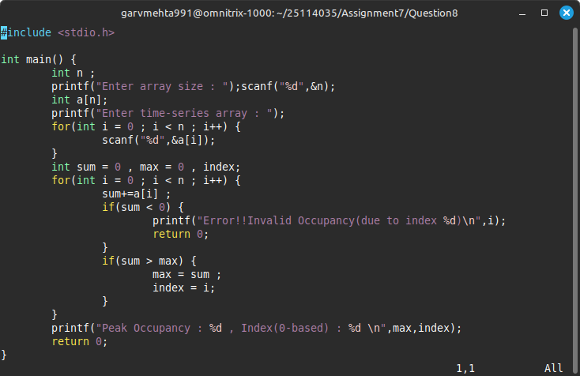

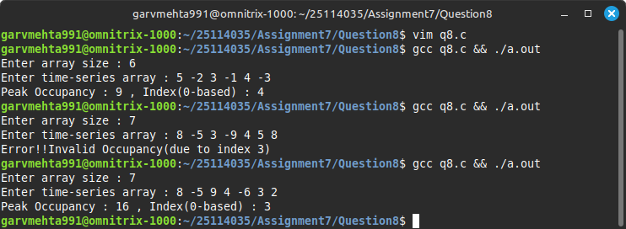

Q-9) You're given the prefix sum array of an unknown array. Write a C program to reconstruct the original array.

Input: [3, 8, 12]
Output: [3, 5, 4]
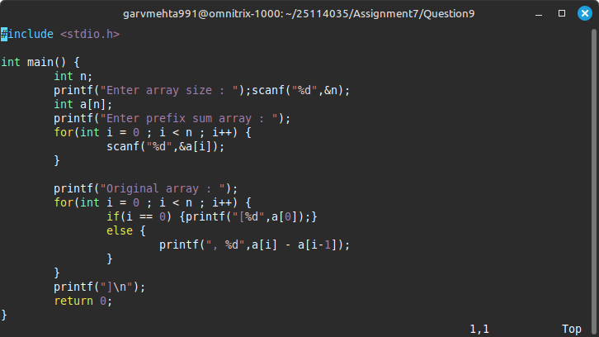

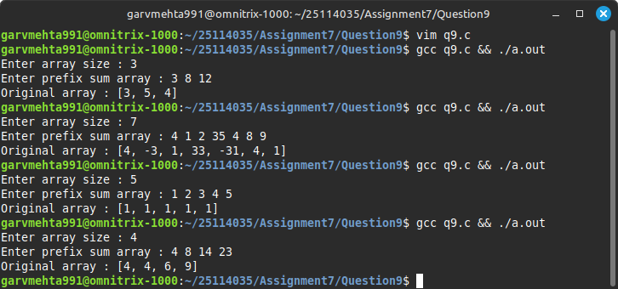

Q-10) Given an array and a window size k, write a C program to output an array of the maximum values for each window.

Array: [1, 3, -1, -3, 5, 3, 6, 7]
k = 3
Output: [3, 3, 5, 5, 6, 7]

